Lab 10 – PHP, XML, AJAX, MySQL

# Purpose

* Explore XML using PHP
* Connect MySQL database using PHP and AJAX
* Upload your website to a Web server

# Due Date

* This lab must be handed in:

**Friday Apr 12, 2019 – before midnight**

# Assessment

* This Lab is worth 2% of your total course mark.

# Assigned Readings

Use the slides and examples found on Brightspace. Module 5 (Part 3, Part 4)

# Lab Supplies

To complete this lab you will require the following lab supplies:

* Textbook: Fundamentals of Web Development
* EasyPHP, or other WAMP server
* Eclipse, Notepad (or other text editor, or IDE)
* FileZilla (or other FTP client)

# Summary of Tasks

1. Develop the logic to display your web application
2. Upload your website to the webserver
3. View your webpage using a web browser
4. Submit Assignment Link on Brightspace
5. Submit Source Code of the PHP files on the Brightspace

# Task 1 (Implement CLF)

Before getting started with the following tasks, review the ‘Common Look and Feel (CLF)’ video provided on Brightspace (under: Course Content 🡪 Extra Materials). Using the knowledge gained in these materials, implement the following Design Pattern to create a ‘Common Look and Feel’ to be used on every page of your website.

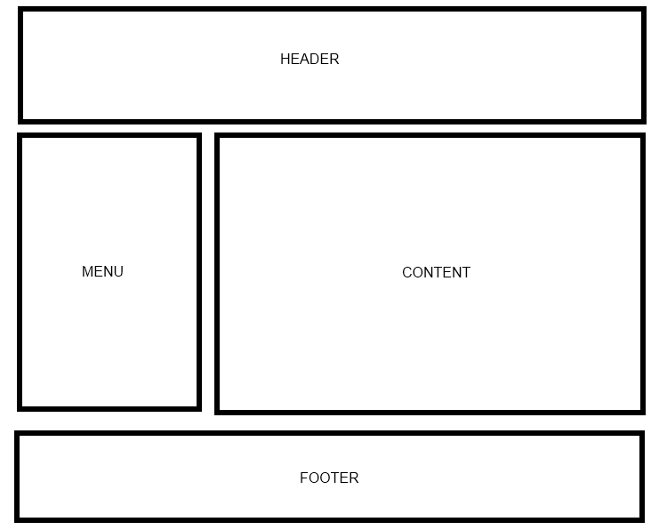

Your web site will include the following scripts:

* Header.php
* Footer.php
* Menu.php
* Books.php
* Employee.php

**Header.php**

Header.php must contain a script to display a Common Header that will appear on every page. The header must contain a banner (images, css, etc).

**Footer.php**

Footer.php must contain a script to display a Common Footer that will appear on every page. The footer must contain Student Number, First Name, Last Name, and Email Address.

**Menu.php**

Menu.php must contain a script to display a Common Menu to be shown on every page. The menu must contain links to Books.php and Employee.php

# Task 2 (Implement Books.php)

Create a page that displays all the content from the following XML file.

<http://www.rejaul.com/CST8238/Lab10/Books.xml>

Use PHP to download the contents of the file and create a table to display each book in the catalog element. Each row in the table should contain all of the Books’ information.

A full example about how to do this can be found on Brightspace: XMLCodeExample.zip

The expected output is as below:

|  |
| --- |
|  |

**NOTE: Books.php must include the Common look and feel implemented in Header.php, Footer.php and Menu.php.**

# Task 3 (Implement Employee.php with the aid of GetEmployee.php)

You need to implement a web page that can fetch information from MySQL database using AJAX. To accomplish this, you need to connect MySQL database using PHP and AJAX.

In this lab, you need to re-use the ‘Employee’ table that you have already created for your Lab 9.

Sample screenshot of the ‘Employee’ table is as below:

|  |
| --- |
|  |

**N.B.:** You may have different data in your ‘Employee’ table. But you need to make sure that there are at least 5 employees in the ‘Employee’ table of your own database.

First, you need to design Employee.php as below:

|  |
| --- |
|  |

Clicking ‘Select an employee’ should display the name of the employees in the dropdown list as below:

|  |
| --- |
|  |

Then, inside Employee.php, you have to implement a function that will invoke GetEmployee.php to retrieve the information of the selected employee from the database.

When a user selects an employee from dropdown list, all information related to the selected employee need to be retrieved from the database and displayed inside Employee.php.

Sample output 1:

|  |
| --- |
|  |

Sample output 2:

|  |
| --- |
|  |

Sample output 3:

|  |
| --- |
|  |

Sample output 4:

|  |
| --- |
|  |

Sample output 5:

|  |
| --- |
|  |

**N.B.:** Sample output may be different depending on the entries of the ‘Employee’ table of your own database.

**NOTE: Employee.php must include the Common look and feel implemented in Header.php, Footer.php and Menu.php.**

# Task 4

Upload your website to the Web server. Use an FTP client to connect to your Web server.

Once you connect to the webserver using an FTP client, create a directory called ‘/CST8238/Lab10’. Once your course directory has been created navigate to that new directory. Add your Books.php, Employee.php, and GetEmployee.php files to this location. (Using FileZilla simply drag the above mentioned files into your folder).

# Task 5

View your website using a web browser. Open a web browser and navigate to the following web address:

**http://web-server_domain_name/CST8238/Lab10/<filename>**

For example, the web address to my page is:   
  
<http://profrejaul.com/CST8238/Lab10/Books.php>

<http://profrejaul.com/CST8238/Lab10/Employee.php>

Where ‘profrejaul.com’ is the domain name of the Web server, ‘ /CST8238/Lab10’ is the name of the directory I created in the Web server using FTP client and ‘Books.php/Employee.php’ is the web page I created for this lab.

# Task 6

Once you have confirmed that your webpage is available online, you are ready to hand in your lab.

Create a compressed file (**Lab10.zip**) which will contain the following PHP files:

* Header.php
* Footer.php
* Menu.php
* Books.php
* Employee.php
* GetEmployee.php

Create a word document (**Lab10.doc**) in which write the following Information:

* Student Number
* First Name
* Last Name
* The URL, or hyperlink of the home page (Books.php) of Lab 10

To hand in your lab go to Brightspace and navigate to Content 🡪 Labs and click on Lab 10 – PHP, XML, AJAX, MySQL’ link.

Upload the word document (**Lab10.doc**) and the compressed file **(Lab10.zip**) on Brightspace.

Finally, click the ‘Submit’ button to send the lab to your professor.

**IMPORTANT NOTE**:

If the URL, or hyperlink, does not direct the professor to the lab you will receive a **ZERO** for the lab assignment.

**IMPORTANT NOTE:**

You may only submit a Lab ONE TIME. Be sure the lab is complete before clicking on the ‘Submit’ button.